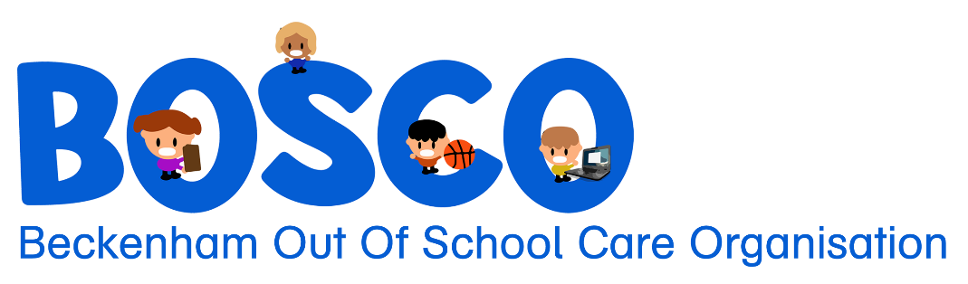
71 Sandwich Rd, Beckenham
Christchurch, 8023
027 645 6632
office@bosco.org.nz
www.bosco.org.nz
Charitable Status: CC40574

Childs Name:
PARENTS/CAREGIVERS
 | PARENT/CAREGIVER 1 | PARENT/CAREGIVER 2
FIRST NAME:
SURNAME:
RELATIONSHIP TO CHILD:
HOME ADDRESS:
HOME PHONE:
MOBILE PHONE:
EMAIL:
OCCUPATION:
PLACE OF WORK:
WORK PHONE:
LIVES WITH CHILD?

MEDICAL/HEALTH/ALLERGIES
Are there any medical, health or allergies that we should know about?

GETTING TO KNOW YOUR CHILD
Describe your child’s personality:

What makes your child happy?

What makes your child sad?

What does your child like to do in their free time?

Does your child play sport or have a favourite hobby?

Does your child have a favourite toy or game?

How does your child handle new or unfamiliar situations?

Is there anything else we should be aware of? For example, is your child shy, anxious, neurologically diverse and if so, how best can we support them?

TRANSITION TO BOSCO
What can we do from our side to help your child settle in to BOSCO?

Does your child have any additional needs (physical or emotional) that we as staff should be aware of that will make the transition to BOSCO easier for your child?

GENERAL
Did you provide BOSCO with two Emergency contacts other than the parents or Caregivers?
YES / NO

GIVE REASON IF THE ANSWER IS NO:

Have you read BOSCO’s terms and conditions?
YES / NO

If required do you give us consent to contact your child’s teacher or school, present or previous?
YES / NO

Do you give us permission to take photos of your child that would appear on our closed Facebook group?
YES / NO

Do you give us permission to take photos and share them on our website?
YES / NO

What are your expectations of our programme?

DECLARATION
I DECLARE THAT I HAVE READ AND UNDERSTOOD THE TERMS AND CONDITIONS OF BOSCO INCORPORATED.

PARENT/CAREGIVER’S SIGNATURE: DATE:

